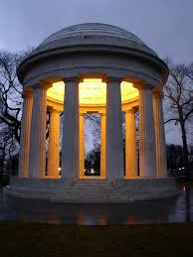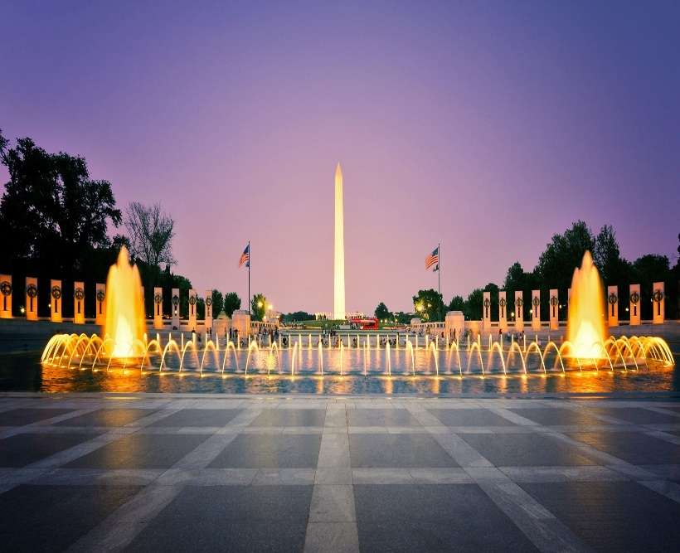
The Rockville
Patriot Newsletter
Henderson-Smith-Edmonds Post 86| Volume 1 Issue
Bi-Monthly Updates
November - December 2021
In the Spotlight
Commander’s Report
Calendar of Events

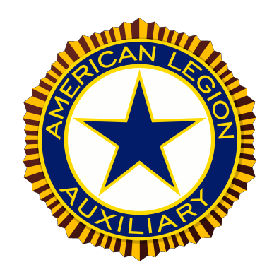

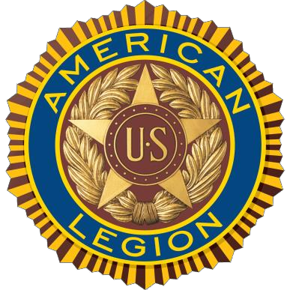

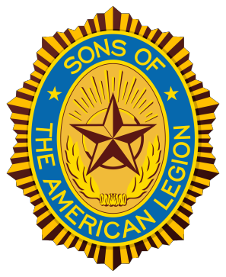

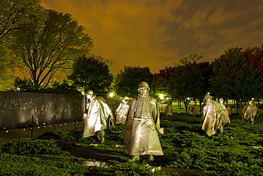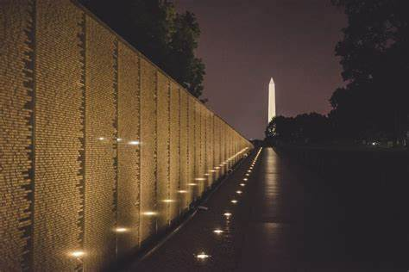

Arlington National Cemetery to mark 100th anniversary of Tomb of the Unknown Soldier

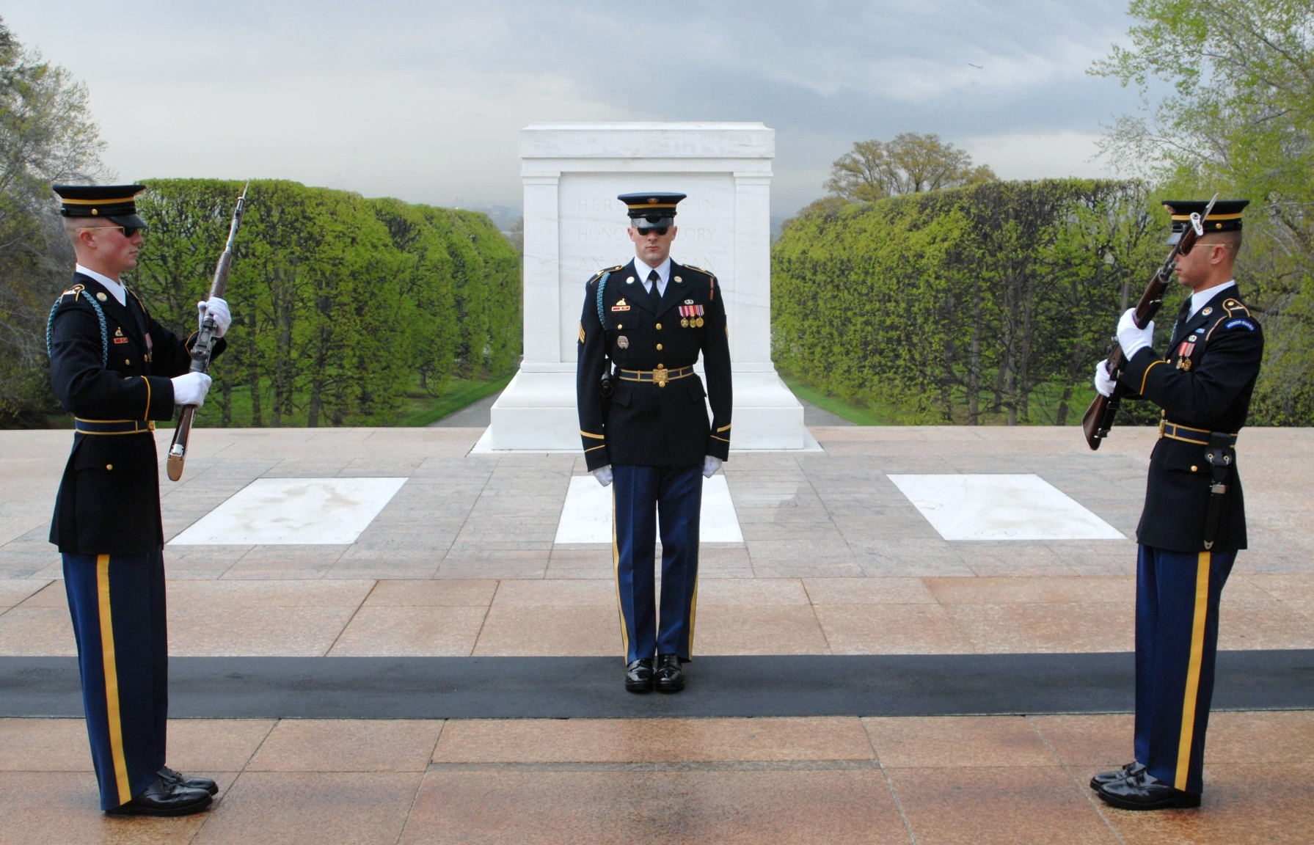
The public is invited to observe a historic procession and flyover on Veterans Day, Nov. 11
ARLINGTON, Va. — Visitors to Arlington National Cemetery will have the opportunity to both re-create history and make history this Veterans Day.
On Nov. 11, the cemetery is holding special ceremonies to mark the 100th anniversary of the Tomb of the Unknown Soldier. The public is invited.
The cemetery will host a full honors procession and joint service flyover beginning at 9 a.m. Troops representing all branches of the military will take part. The procession will begin at the cemetery's main entrance on Memorial Avenue near the Welcome Center. Troops will proceed west to the gates of the cemetery and make their way to the base of the plaza on the east side of the Tomb near the Roosevelt Fountain.
00:14 / 06:01
The joint service flyover will take place over the cemetery during the procession. Aircraft formations from each service will honor the Unknown Soldiers.
“One hundred years ago, on November 11, 1921, the World War I Unknown Soldier was transported by a procession to his final resting place in Arlington National Cemetery," said Karen Durham-Aguilera, the executive director of the Office of Army Cemeteries and Arlington National Cemetery. "This year, we are recreating elements of that procession, and we invite the public to observe this pivotal moment in American history as thousands of Americans did in 1921."
The anniversary procession is free. No tickets are required. But visitors must have a government-issued ID for access and must arrive along the parade route no later than 8:45 a.m. The route is ADA-accessible and stroller-friendly. Ceremonies will take place rain or shine.
Due to COVID-19 protocols, a Presidential Armed Forces wreath-laying ceremony will be invitation-only, taking place after the procession and flyover.
Arlington National Cemetery is also hosting a special Public Flower Ceremony in the days leading up to Veterans Day. Visitors will have the rare opportunity to lay flowers at the Tomb of the Unknown Soldier from 9 a.m. to 4 p.m. on both Nov. 9 and Nov. 10. The event is free.
Visitors are encouraged to bring their own flowers, but complimentary flowers will be distributed. Registration is required at EventBrite.com: https://anctomb100.eventbrite.com/.

COMMANDER’S REPORT  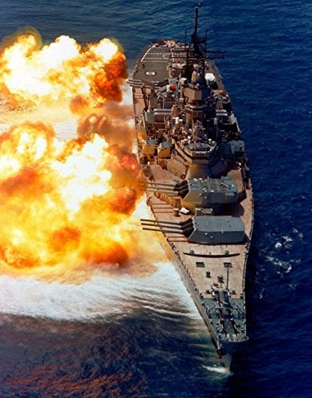  November marks the beginning of the holiday season and is a month jam-packed with events. On the 7th we turn back our clocks one hour and are forced to endure the short days and lack of sunshine. We say goodbye to trips to the beach and many outdoor activities and begin looking forward to Spring, but there are also some good things that happen during the month.  November 10th is an eventful day for the American Legion. It marks the 102nd birthday of the Legion Auxiliary and is also the birthday of the United States Marine Corp. On this day in 1775 The Continental Congress ordered the formation of the Marines who have participated in all wars involving the United States. Happy Birthday! Semper Fi. November 11 is designated as Veteran's Day honoring all who have served in the Armed Forces. We will celebrate at the Post with food and Happy Hour prices for all our members and will pay tribute to our time in service to our country.  Thanksgiving is a special holiday on the 25th. The last 18 months have been difficult for all of us and some have lost friends and relatives to COVID-19. We can be truly thankful for our health and our families this year even though we are still dealing with the pandemic.  The "new normal" is difficult for everyone and the lack of supplies that we have always taken for granted is frustrating. Still we should be thankful for what we have and for the fact that we have been able to get through these tough times. We will, as usual, feast on the delicious seasonal food and watch football until our eyes blur but we must remember and be grateful for all the freedoms and privileges that we enjoy living in the United States.  Happy Hanukkah to all our Jewish members on the 29th. May your new year be filled with happiness and good fortune. I wish all of you a wonderful and memorable holiday season. Even though hugging is discouraged, do it anyway. Enjoy your friends and family at this magical time and have a happy Thanksgiving Holiday.  December 7th, 2021 the Fleet Reserve Association will be holding a Pearl Harbor Memorial Service. On December 11th, we will watch the Army Navy game like in years past December 25th, falls on a Saturday this year and I would like to Wish everyone Happy Holiday and a Blessed New Year.  Good luck to all four Units as you take on the work of The American Legion. I'm confident that we will achieve all our goals and have a prosperous 2022.  Those in Need If you know a veteran, active duty military or Legionnaire who is in need of food assistance, please call Legionnaire our very own Service Officer Roy Davis. All information will be kept confidential.  THOUGH TIMES DON’T LAST TOUGH PEOPLE DO!!  For God and Country,  Robert Hebron  Commaneder  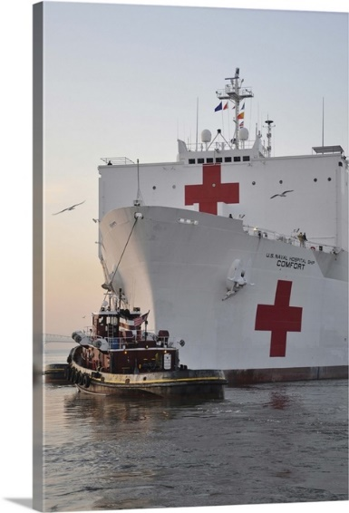  THE DESK OF THE 1st VICE COMMANDER  Membership:  The Post is getting an excellent response for renewal and new Comrades joining our Post. We are presently 64.074% and moving ahead of our November 2021 goal which is Excellent. If by chance you get a 2nd notice in the mail to renew, disregard it if you know that you already paid. The 2nd notice means that National has not gotten your renewal from Department yet. If you haven't paid, please do. Pay online, bring it to the Post, or mail it to the Post. As soon as I get it, I will mail your new Card to you, if you come to the Post and I am there; I will get you your new Membership Card while you enjoy a cold one or visit with the Patrons who are already there. I would like to see all our Membership be accomplished by March of this year at 100%. With your help, we can accomplish this task together. When filling out your 2022 | MEMEBERSHIP INFORMATION  Please sign-up or pay your Legion Year 2021-2022 Post, SAL or Auxiliary dues. Legionnaire dues are $40.00 and can be paid either online or by cash or check. SAL dues are $25.00, Dual members $25.00, and Juniors (under 21) $15.00. Auxiliary dues are $30.00; Juniors (under 18) are $15.00 and Legion Riders are $25.00. Any Legion Home member who has not paid their 2021 dues by January 1, 2022 will be in arrears and will not be issued a key card and MUST sign in as a guest when visiting the Post Home. If you are in arrears, you must pay the previous Legion Year dues to be in good standing. If you are not in good standing, you are not eligible for the drawings, voting and other privileges. Our Membership renewal drive is in progress. Let’s be 100% again!  For God and Country,  Robert Hebron  Past Commander  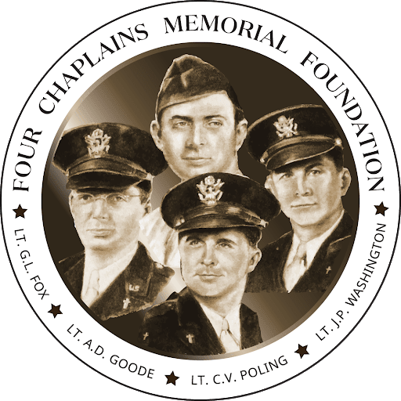  Chaplain’s Corner  Well, as the Holiday season fast approaches Let’s keep our positive outlook and resolutions that will insure 2022 is better than 2021. COVID-19 reigned the majority of 2021 but that does not mean we should not take time to reflect on achievements and relationships in the past and look forward to the future. As the dawn breaks on a new year let us give thanks for all we hold dear, our health, our family and our friends. Let us release all our grudges, anger and pain. Let’s live each day in the way God has taught us. Do unto others as you would have them do unto you. May 2021-2022 Legion year be filled with the blessings of peace, prosperity and love for all.  Past County & Post Commander  For God and Country,  Levelle Ferrell  membership renewal please provided an updated mailing address and email address to ensure you receive the latest updated information on our post. Please go out and try to get at least one person to join our Family here at Post 86.  Now, if by chance you need to renew your dues, which are $40.00: please pay now so Post 86 can be 100% by the due date to remain is good standing. If you 40 Comrades who still owe their dues for 2021, paying now will help everyone as I stated before So, as your 1st Vice Commander; I am asking you to try to do this task in order to help Post 86.  For God and Country,  Randy L. Phillipp PPC  1st Vice Commander  ADJUTANT’S UPDATE  A warm and joyful hello to all my comrades!!! It is such an exciting time. Life is back to normal at our Post - YEAH!!! I still can’t get used to getting up from my table without a mask!!! I always feel like I’ve forgotten something. Like when you drive off and then remember you forgot to put on your seatbelt. We have all kinds of upcoming events planned. There’s something for everyone to get excited about. Many, many reasons to come to your Post. If you aren’t in a partying mood, come and lend a hand helping at an event. Keep current with all the happenings by reviewing the multiple postings. It is important to ensure we order enough food and supplies for everyone who wants to attend an event. Your strict attention to this issue is greatly appreciated.  That’s all for this month folks. Will do my best to keep you up to date on happenings, as applicable to an Adjutant. I’ll try to get some fun stuff in when I can!!!  Still, stay safe, get vaccinated if you choose and see you all at our Post...  Remember also, the Bartender oversees the Lounge when on duty.  For God and Country,  Randy L. Phillipp PPC  Adjutant
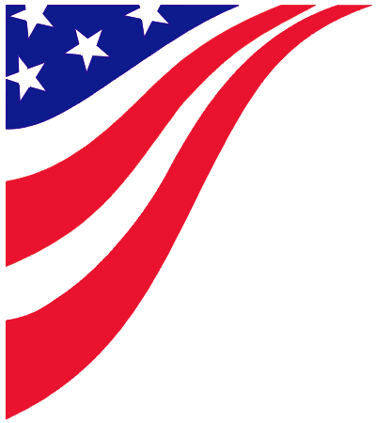

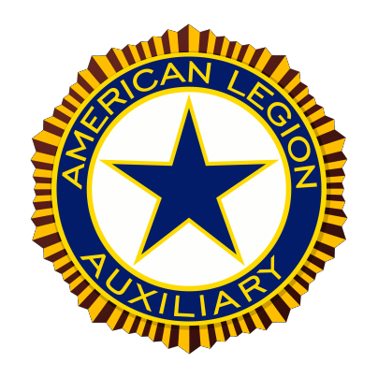

Auxiliary Unit 86 Corner
The New Officers for year 2021-2022:
President, Carolyn Davis PMP
First Vice President, Maryann Holmes PMP
Second Vice President, Electra Stathes
Secretary, Diana Martin
Treasurer, Dana Pettenatti & Kristy Brinkley
Chaplain, Electra Stathes
Sergeant-At-Arms, Katie Hopkins
Executive Committee, Sue Sumner, Diana Martin,

Greetings from Unit 86,
Hope everyone had a Great and Safe summer.
Our Next meeting is on Sunday November 7th, 2021 @ 12:00 pm. Our next dinner will be on Friday November 12th, 2021 from 5:30 pm – 8:00 pm or until sold out. We will be serving a Turkey dinner with all the fixings.

The Sons of the American Legion will be starting breakfast again, starting on November 7th, 2021 from 09:00 am to 1:00pm

The post will be hosting their second Blood drive on November 15th, 2021 from 10:00 am to 4:00 pm. If you are interested in donating please contact Doug Campbell at the post or by e-mail at dougcampbell@mdlegion86.org.

Please remember to pay your dues Seniors $30.00 Juniors$ 6.00.

Have a Safe and Happy Holiday Season.
Yours in Service,
Carolyn Davis
Auxiliary President/ PMP
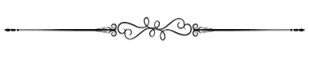
American Legion Auxiliary
Service not Self 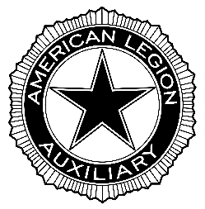

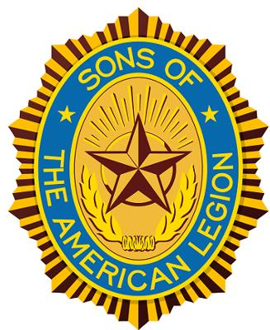
Squadron 86 Report

Henderson-Smith-Edmonds Squadron 86
Dues are $25; $10 (20 and younger)
Meeting First Tuesday of Every Month

Membership All male descendants, adopted sons and stepsons of members of The American Legion, and such male descendants of veterans who died in Service during World I, World War II, the Korean War, the Vietnam War, Lebanon, Grenada, Panama, the Persian Gulf War and the War on Terrorism, during the delimiting periods set forth in Article IV, Section 1, of the National Constitution of The American Legion, or who died subsequent to their honorable discharge from such service, shall be eligible for Membership in the Sons of The American Legion. There shall be no forms or class of membership except an active membership.

SAL Squadron 86 Leadership

Commander - David Holmes
1st Vice Commander - Doug Campbell
2nd Vice Commander - Cully Pettenati
3rd Vice Commander - Collins Murphy
Adjutant - Ken Pegher
Chaplain - Greg Dix
Executive at Large - Bill Bird
Finance Officer - Doug Campbell
Historian - Carl Maxin V
Post 86 Advisor - Rob Hebron
Sgt-at-Arms- Nick Campbell

Hello SAL Squadron, 86 & Post 86 Family,
The SAL appreciates all who come out to support us and the legion during our dinner nights. Our dinner on October 15th sold 29 meals. The Dinner on Nov 19th will be stake, mashed potatoes, and a vegetable. There will not be a SAL dinner on December 17th. We have dinner every 3rd Friday of the month starting at 5:30 pm, call the legion at 301-424-4486 for more information about what we will be serving and the price, or visit the Post 86 Facebook page.
On the 3rd Sunday of every month the SAL participates in the Adopt-A-Road Program. We are responsible for cleaning Aspin Hill Rd; volunteers are welcomed and appreciated. Meet at the post at 9:00 am, where we will caravan to the clean-up location. Clean up days are weather permitting, if there is a case of rain, snow, extreme temperatures, etc. the event will be cancelled.
SAL meetings occur on the 1st Thursday of every month. Those who hold an officer position within the SAL are required to attend, unless excused in advance. All SAL members are welcome to attend meetings to find out what the SAL has planned and what you can do to help support the Squadron and the Post.
The Post 86 website is currently under construction to get some much-needed improvements. There is a section devoted to the SAL that contains information about the organization as a whole, located under the “Join The Legion” tab. Users can view what events/meetings are upcoming for the SAL and Post Family, via the calendar tab. Visit https://mdlegion86.org/ , (Information on the website is subject to change). For any concerns about the website please contact the SAL Historian Carl Maxin V at carlmaxinv@gmail.com .
If you have not yet renewed your dues the cost is $25.00. Exact cash and check are accepted and can be delivered to out 1st Vice Commander/Finance Officer Doug Campbell. Renewal reminders have been sent out to those with outstanding dues. Doug will be bartending every Tuesday. The 1st Tuesday of every month he will be donating his tips to Post 86, and he will be running a food special. If there are any changes to your contact information or concerns about paying your dues, please contact dougcampbell@mdlegion86.org .
For any questions, comments, or concerns, about the SAL Squadron 86, please contact the SAL Commander David Holmes via email, call, or text, at dmholmes1276@gmail.com or 240-277-8554.

SAL Commander
David Holmes

2019-2022

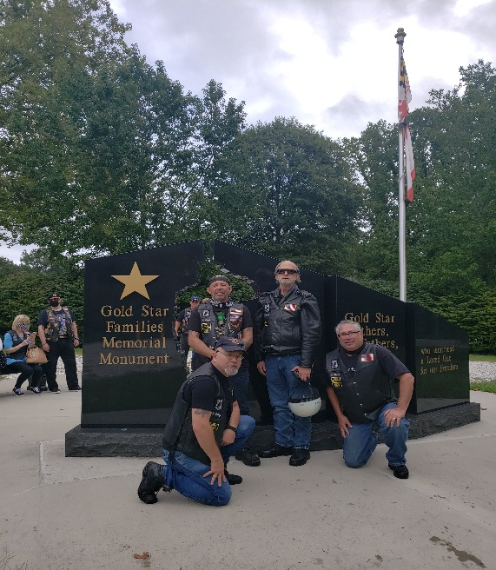

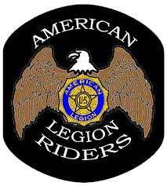

Greetings Post Family,
Another riding season has come to an end and with the support of many people we had a very successful year. We were able to donate $2700 to the legacy scholarship fund this year. We also supported several other posts with their events.
I am pleased to announce that the state Legion Riders meeting will be held at our post on March 19, 2022. We will also be having our blessing of the bikes in March possibly in conjunction with the meeting.
The Riders are still serving a dinner the second and fourth Wednesday of the month. If there is something that you would like to see served do not hesitate to contact myself or another member of the riders with your ideas.
Please remember that we are still collecting donations for the legacy Scholarship fund and that all donations are tax deductible. Please donate if you can.
The riders will not be serving dinner the fourth Friday of November and December dur to the way the holidays fall this year, but we will be back in January with another of our delicious meals.
Membership in the riders is open to any post family member in good standing that rides. Support memberships are also available. Current members need to renew their membership when they can. Currently dues are $20 per year.

Remember that together we can make great things happen.
Thank You for your support this year.

David R. Bean

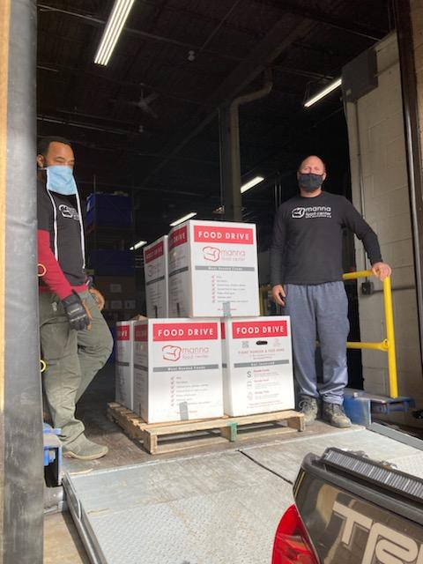  Manna relies on the generosity of our community to help provide the money needed to keep our trucks fueled and running, our refrigerators and freezers operational, and the warehouse stocked with the supplies and essential food needed to help those suffering from hunger in our community. I am ecstatic about the support from the Post Family we collected 8 donation boxes totaling 638 lbs. of donated non-perishable food product well done Post Family  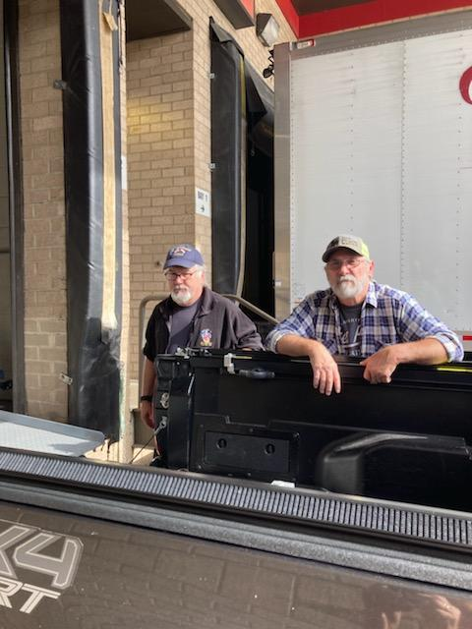 | 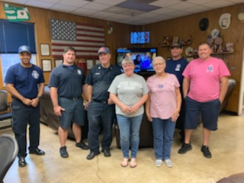  October 28th, 2021 was National First responder Day.  First responders dedicate their lives to save lives. They are the people who run toward a crisis while the rest of the world flees. According to the Department of Homeland Security, 4.6 million career and volunteer first responders support the communities where they live. They are firefighters, police, emergency medical technicians (EMT), paramedics, and 911 operators. In an emergency, they’re the first on the scene. These dedicated professionals answer the call when a crisis arises, often putting their own lives on the line.  The Post Family contributed our part to Honor these Brave Men and Women. The Sons of the American Legion graciously prepared, cooked and donated an amazing meal for Station 23 in appreciation for all they do throughout our community.  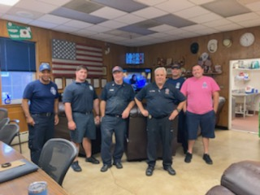

Lifeline Screening being held at A.L. Post 86
will be on Wednesday, December 8th, 2021 from 9:00 AM - 4:30 PM.

Our Mission
Awareness and early detection of disease is powerful. That’s why our purpose is to make you aware of unrecognized and potential health problems and encourage follow-up care with your personal physician to strengthen their understanding of your total health.

Our Commitment
We deliver health information you can trust, with technicians and environments that are safe, effective and certified.
- Board-certified physicians, licensed in your state, will review most screening results
- Abnormal screenings are reviewed by a second technologist
- Random audits of screening results are performed frequently
- Physicians routinely review their peers' screenings
- CLIA-certified lab
- Our vascular screenings have been independently verified in side-by-side studies in hospitals in both the United States and the United Kingdom.

Cathy Bush
Health Service Coordinator
Life Line Screening
Phone: (800) 897-9177
If you wish to register for the screening online go to www.lifelinescreening.com/communitycircle

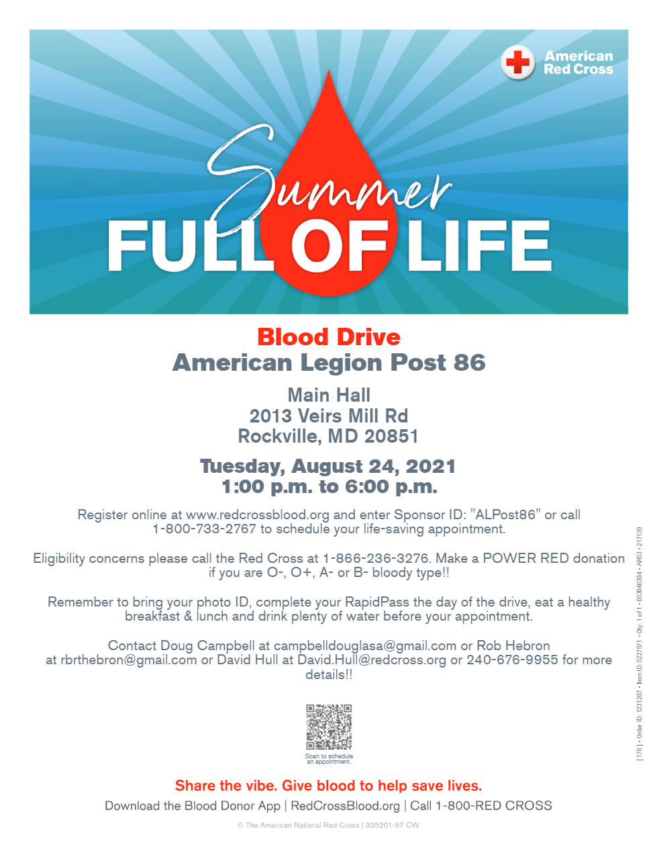
Monday November 15th, 2021
10:00 AM to 4:00 PM

From Our Friends

Post 86 opens our doors to many organizations. Below are upcoming meetings and events from some of Our Friends.

Disabled American Veterans, Rockville Memorial Chapter #12
Meetings are on the 1st Wednesday of every month at 1930 hours (7:30 PM).
The Disabled American Veterans, or DAV, is an organization chartered by the United States Congress for disabled military veterans of the United
States Armed Forces that helps them and their families through various means. It currently has nearly 1.3 million members. - Wikipedia

Marine Corps League, Sgt. John 'Jack' Hettchen, Jr. Detachment
Meetings are on the 2nd Tuesday of every month at 1930 hours (7:30 PM)
The Marine Corps League is the only c congressionally chartered United States Marine Corps-related veteran’s organization in the United States. Its Congressional Charter was approved by the 75th U.S. Congress and signed by President Franklin D. Roosevelt on August 4, 1937. The organization credits its founding in 1923 to legendary Marine Corps Commandant John A. Lejeune. - Wikipedia

Fleet Reserve Association
Meetings are held the 3rd Wednesday evening of every month from 7 -8:30. If you were enlisted and served in the Marines, Navy and Coast Guard, you are eligible to join.
The Fleet Reserve Association (FRA) is a congressionally chartered, non -profit organization that represents the interests of the Sea Service
Community before the U.S. Congress. – https ://www.fra .org/fra /We b/About_FRA/We b/About_FRA.a s px

Sons of the Confederate Veterans
Meetings are on the 1st Tuesday of every month at 1930 hours (7:30 PM)

The public are welcome to attend.

Organized in 1896 by the sons of the Veterans themselves, the Sons of Confederate V veterans (SCV) serves as a historical, patriotic, and non -political organization dedicated to ensuring that a true history of the 1860's is preserved for future generations. The SCV offers local l, state, and national programs including historical preservation, marking and maintaining soldiers’ graves, presentations and publications, all striving to maintain the integrity of American history.
Membership is open to male descendants of Confederate Soldiers, Sailors and Government Officials, regardless of race, color, creed or background. The SCV exists to honor American and Southern history and rejects and condemns the misuse of any modern or historical symbols for hate. Many of our members belong to other historic and patriotic groups such as the Sons of American Revolution and local Historical Societies. We would be honored to have members, guests, and friends of Post 86 attend any of our activities. - Bob Brewer, Past Commander

Fun and Games

Sunday Afternoon Bingo

Sunday Afternoon Bingo IS BACK!!!! Starting September 12^{th,} 2021 from 2 pm to 5 pm Sunday Afternoon for your Bingo entertainment. Mark your calendars please. Every Sunday we have plenty of opportunities for our patrons to win some great cash prizes. Our Bingo program consists of 25 games and usually runs about three hours and fifteen minutes. Everyone of age is eligible to play and we will sell three to four boxes of tickets every Sunday Afternoon before our event starts. If anyone wants to play, they should plan on being at the Post by 1:30pm as these games usually sell out very quickly. Come on out this month and support your Post by playing Bingo on Sunday Afternoons. Questions about our program can be directed toward James or Randy and we’ll be happy to answer them. Your Bingo Team members are here for you.

Washington Area Darts Association
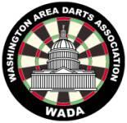

Post 86 hosts two teams from Washington Area Darts
Association (WADA) since last fall. They play Wednesday
nights starting at 7:00 PM. There are three “seasons” a
year, January-April, May-July, September-December.
Sponsoring two teams’ costs $144 per Season. If anyone is
interested in starting another team or playing, please
come down and visit on a Wednesday night.

ACE OF SPADES

We were able to start the Ace of Spades is a little over $318 dollars so come on down on Fridays and take a chance. There is plenty of room for social distancing so bring your pull tab fingers and lucky X-ray glasses to pick the Ace of Spades. Karry and her gang are looking forward to seeing you. All other events are either cancelled or on hold. Please look here next month or on Facebook, Twitter, or Instagram for updates
Clubhouse

Additionally, there is a suggestion box on the wall by the door leading into the offices (all suggestions must be signed). If it’s of an immediate nature, see a Post Officer. Of note, if a Post Officer has been at the Post socializing for a period of time and had several liquid refreshments, they are discouraged from making command decisions while in a less than optimal condition. Remember also, Hours are dependent on number of patrons. Bartenders have full authority in the clubhouse area.

Commander's Last Shout!!!  A man once said, “Success is a process for all of us, and as long as you are making consistent progress towards your goals – sincerely giving your best effort more often than not – then you are already successful and deserve to feel proud of yourself.”  I want to thank the Post family their continued support throughout our community, our veterans, and our programs. Each day bring on a new task for success. Even during these confusing and frustrating times. Thanks most of all to the ALL 4 Units who continued to do the work of the American Legion. We can all be proud of what we have accomplished this year thus far. I know whole heartily that together we will make 2022 Legion year a Great One.  Congratulations go out to the Following people: Electra Stathes Auxiliary Member of the Year, Doug Campbell Sons of the American legion Member of the year, and David Bean American Legion Rider of the Year. Your Commitment to the American Legion and each of its programs show a true testament of what the American Legion was founded on.  Remember to check us out Facebook, Twitter, & Instagram for all updates and events. | The Post#86 newsletter  is published bi-monthly for  Jan – Feb; Mar – Apr; May – Jun.  Jul – Aug; Sep – Oct; Nov – Dec.  Henderson-Smith-Edmunds Post 86, Inc.  Special editions are published when necessary  Individual ideas and viewpoints  expressed are not necessarily those of  Post 86.  Post 86 is located in the Twinbrook neighborhood at:  2013 Veirs Mill Rd  Rockville, M D 20851
Post Meetings Executive Committee 7:00 pm First Thursday

General Membership 7:00 pm Second Thursday Note: Except the 2nd Thursday in July due to Convention

Auxiliary Unit 86 General Membership 12:00 pm First Sunday

SAL Squadron 86 7:00 pm First Tuesday

American Legion Riders 7:00 pm Third Tuesday

 | For members who do not have E-Mail If you want the Post Newsletter mailed to your home, please send the written request by mail to the Post Adjutant.
We e-mail the website link for our Post Newsletter and other items of interest to members that have access to e-mail and the Internet. Please send your e-mail address to: rbrthebron@gmail.com and it will be added to our email list. Your e-mail will be used for Post 86 notifications only, it will NOT be given out to solicitors.

Post Phone: (301) 424-4486 Website: http://info@mdlegion86.org

Post 86 Officers  Commander Rob Hebron  1st Vice Randy Phillipp  2nd Vice Ethan Simon  3rd Vice Brian Wolford  Public Relations Eric Bernard  Judge Advocate Paul Angell  Finance Officer Martin Begosh  Chaplain Levelle Ferrell  Service Officer Roy Davis  Historian As Appointed  Sgt-At-Arms Tim Allman  Adjutant Randy Phillipp | Auxiliary Unit 86  President Carolyn Davis.  1st Vice Maryann Holmes  2nd Vice Electra Stathes  Secretary Diana Martin  Treasurer Dana Pettenatti & Kristy Brinkley  Chaplain Electra Stathes  Historian As Appointed  Sgt-At-Arms Dolores Lightcap  Executive Committee Sue Sumner, Diana Martin, | SAL Squadron 86  Commander David Holmes 1st Vice Doug Campbell  2nd Vice Cully Pettenati  3rd Vice Collins Murphy  Finance Doug Campbell  Chaplain Greg Dix  Sgt-At-Arms Nick Campbell  Historian Stephen Maxin Adjutant Ken Pegher  Advisor Rob Hebron | Legion Riders 86  Director David Bean  Asst Dir. Ken Pegher  Sec. Patti Mackie  Treas. Stephanie Bean Chaplain Rob Hebron

NOVEMBER | Monday | Tuesday |  | Wednesday | Thursday | Friday | Saturday
2021
Sunday | 1  POST  OPEN 1st MONDAY of EVERY MONTH | 2  NAM Knights  Squadron 86  SCV, & DAV  1900 Hrs. | 3 |  | 4  Post Executive Meeting  1900 Hrs. | 5  Lefty’s Shrimp  5:30 PM - 8 PM | 6
7  AUX MEETING  BINGO  2-5 | 8  POST  CLOSED | 9  MC League  1900 Hrs. | 10  Marine Corps Birthday  Legion Riders Dinner  6 PM - 8 PM |  | 11  Veterans Day  Post General Meeting  1900 Hrs. | 12  AUX Dinner  5 PM - 8 PM | 13
14  BINGO  2-5 | 15  POST  CLOSED | 16  Legion Riders  1930 Hrs. | 17  Fleet Reserve  1900 Hrs.  Legion Riders Dinner  6 PM - 8 PM |  | 18 | 19  SAL Dinner  5 PM - 8PM | 20
21  BINGO  2-5 | 22  POST  CLOSED | 23 | 24 |  | 25  Thanksgiving Day | 26  Legion Riders Dinner  5:30 PM - 8 PM | 27
28  BINGO  2-5 | 29  POST  CLOSED | 30

DECEMBER | Monday | Tuesday | Wednesday | Thursday | Friday | Saturday
2021
Sunday |  |  | 1  Civil Air Patrol (USAF Auxiliary) Birthday | 2  Post Executive Meeting  1900 Hrs. | 3  Lefty’s Shrimp  5:30 PM - 8 PM | 4
5  AUX MEETING  BINGO 2-5 | 6  POST  OPEN 1st MONDAY of EVERY MONTH | 7  Pearl Harbor Remembrance Day  NAM Knights  Squadron 86  SCV  1900 Hrs. | 8 | 9  Post General Meeting  1900 Hrs. | 10  AUX Dinner  5 PM - 8 PM | 11
12  BINGO 2-5 | 13  POST  CLOSED | 14  MC League  1900 Hrs. | 15  Fleet Reserve  1900 Hrs.  Legion Riders Dinner  6 PM - 8 PM | 16 | 17  SAL Dinner  5 PM - 8PM | 18  National Wreaths Across American
19  BINGO 2-5 | 20  POST  CLOSED | 21  Legion Riders  1930 Hrs. | 22 | 23 | 24  Legion Riders Dinner  5 PM - 8 PM | 25  Christmas Day
26  BINGO 2-5 | 27  POST  CLOSED | 28 | 29  Legion Riders Dinner  6 PM - 8 PM | 30 | 31  New Year’s Eve  Legion Dinner  5 PM - 8 PM

BOOSTERS Support Post 86 by being a Booster!
For $10, Boosters' names will be published in six bulletins. For $20, names will be published in twelve bulletins. Remember, there are six bulletins per year. For $20, you will be a booster for two years!!! This opportunity is available to all Legion, Unit and S.A.L., & Riders Members and to all guests of the Post. Please renew your listing by the 15th of the month prior to its expiration. To become a Booster or to renew your listing, see our Adjutant. Thank you for your support.

AMERICAN LEGION POST 86 BOOSTERS
Expires July 2023
Navy Rob & Patti

VOLUNTEER HOURS

Behind every successful nonprofit organization is an awesome team of volunteers, and our Unit has the best! In the spirit of SERVICE, not self-Please remember to keep track of your hours and post them on Track it Forward or send them to rbrthberon@gmail.com All of your volunteer hours helping our veterans, active duty military, their families, and our community count. Don’t forget to keep track of your mileage too, the IRS allows you to deduct 14 cents per mile driven in service of charitable organizations as a charitable contribution. Be sure to check out the IRS requirements for this deduction.

DONATION LETTER
As always, YOUR donations are greatly appreciated to help keep the Post operating, as well as, support the American Legion programs! Remember, your donations are tax deductible!

Henderson-Smith-Edmunds Post 86 Charitable Donation Form
Name: _________________________________________________________
Address: ________________________________________________________
Phone: _________________________________________________________
Email: __________________________________________________________
Enclosed is my donation of: _________________________________________
Make checks payable to: American Legion Post# 86, American Legion Auxiliary Unit# 86, or Sons of The American Legion Squadron# 86, or American Legion Riders Chapter #86.

All donations are tax exempt.
Please send donations to:
Henderson Smith Edmonds
American Legion Post 86,
2013 Veirs Mill Rd.
Rockville, MD. 20851

